ĐỀ THI TIẾNG ANH Mã đề: 05
Trình độ A2
Họ và tên thí sinh: ……………..……………………………………………………….…………………………………………………………
Số báo danh: ……………..…………………………………………...……. Phòng thi số: …………………………….……………

PAPER TWO LISTENING (Approximately 15 minutes)
PART 1: Questions 1 – 5
There are five questions in this part. For each question there are three answer choices and a short recording. Tick (√) the correct answer. You will hear the piece twice.
Example: How many people were at the meeting?
A. 3 B. 13 √ C. 30
1. What colour is Kathy’s bedroom now?
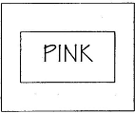
A □ B □ C □
2. Which platform does the woman’s train leave from?
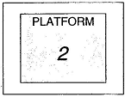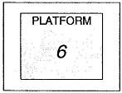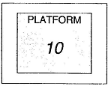
A □ B □ C □
3. How is Susan going to get to the airport?
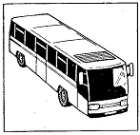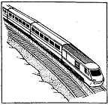
A □ B □ C □
4. Which is Anna’s family?
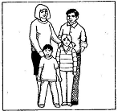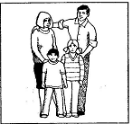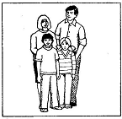
A □ B □ C □
5. When is Kim’s birthday party?
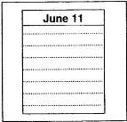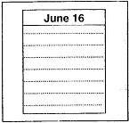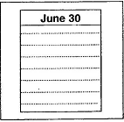
A □ B □ C □
PART 2: Questions 6-10
Listen to Jack and Mark talking about a new sports centre. Which sport can they do each day at the centre?
For questions 6-10, write a letter A-H next to each person. You will hear the conversation twice.

EXAMPLE | ANSWER
0 Monday | D
DAYS |  | SPORTS
6 Tuesday  7 Wednesday  8 Thursday  9 Friday  10 Saturday |  | A badminton  B basketball  C football  D golf  E hockey  F swimming  G tennis  H volleyball

PART 3: Questions 11-15
Listen to Peter talking to a friend about learning to drive.
For questions 11-15, tick (√) A, B, or C. You will hear the conversation twice.
Example: 0. The name of Peter’s driving school is
A. AA
B. AC
√ C. ABC
11. Each driving lesson cost
A. £14
B. £40
C. £60
12. A lesson is
A. 30 minutes
B. 45 minutes
C. 60 minutes
13. The teacher’s car is
A. slow
B. old
C. big
14. Peter failed the course because he
A. drove too fast
B. didn’t see a crossing
C. didn’t stop at the traffic lights
15. Peter thinks the teacher is too
A. expensive
B. unfriendly
C. young

